***Arpit Singh***

***19BCG10069***

***Appointy – Task 1***

***Technical Task***

***(Internship)***

**Steps:**

1. Installing Golang and Setting up the Environment
   1. Install(Setup for windows) golang from Golang.org
   2. Setup the System (Environment) variable as per the desired directory
      1. Use commands: go env; Check GoRoot and GoPath specifically.
   3. For Example: To set workstation as a folder in Desktop set env variable as: *C:\Users\ArpitSG\Desktop\Go-Workspace.*
2. Installing MongoDB and Setting up the Environment
   1. Install(Setup for windows) MongoDB from MongoDB.com( community server )
   2. Setup the System (Environment) variable as per the desired directory
   3. For Example: *C:\Program Files\MongoDB\Server\5.0\bin.*
3. Setup a Connection between MongoDB cluster(Server) and Golang(file)
   1. Import dependencies :
      1. go get github.com/gorilla/mux (For Managing htttp requests)
      2. go get go.mongodb.org/mongo-driver/mongo(For Managing and establishing connection with MongoDB)

**Coding**

Create a file under GOPath Directory

(C:\Users\ArpitSG\Desktop\Go-Workspace\src\Internship\main.go)

Open a text Editor (Atom) and write the following code that just puts in basic data model and outline of our go file.

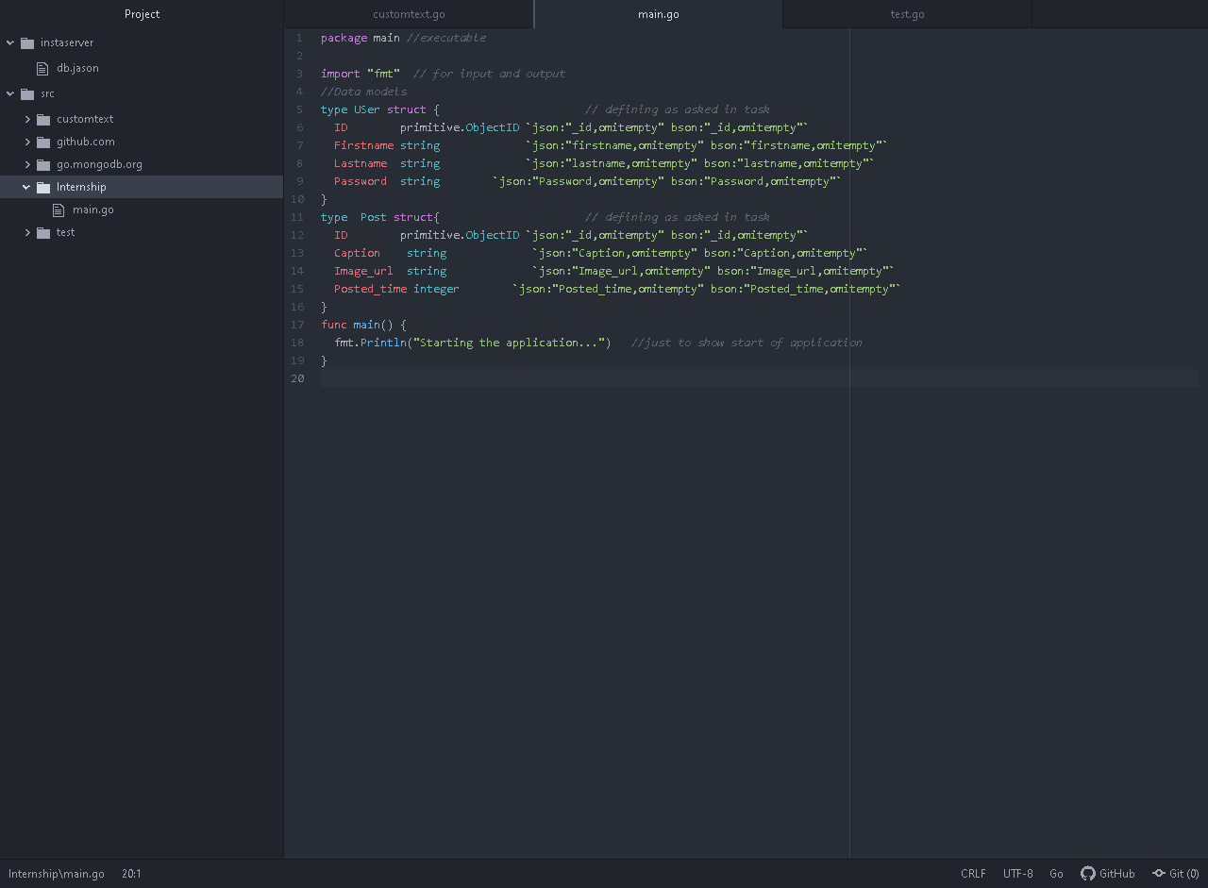

*Json – for user understanding (Web client)*

*Bson – for MongoDB interpretation*

Next lets create a mongo client and establish connection(within main function along with context time) each time a function of our application is implemented.

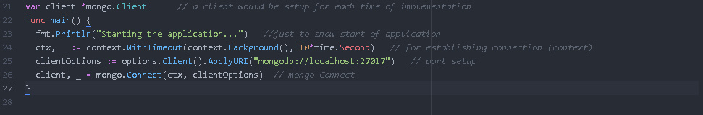

Next lets define the router to complete the connection process with MongoDB by passing in our router and port.

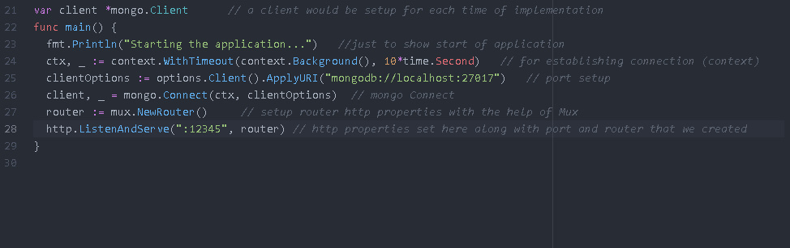

Now lets Check everything is working properly.

To do so lets go to terminal (Cmd) and execute are main.go (file) with:

(go run main.go)

Note you should be in the GoPath file directory

(C:\Users\ArpitSG\Desktop\Go-Workspace\src\Internship\main.go)